Ariyan Behrouz
Dr. Dan Graur
University of Houston

Codon Usage Bias in Escherichia coli: Evidence for Translational Selection Beyond Mutational Pressure

Introduction:
Synonymous codon usage bias refers to the non-random use of synonymous codons that encode the same amino acid. Although synonymous substitutions do not alter the protein sequence, accumulating evidence suggests that the choice of synonymous codons can influence gene expression, translational efficiency, and genome evolution. As a result, synonymous codons are not always evolutionarily neutral. Two primary forces have been proposed to explain codon usage bias. One is mutational pressure, in which genome-wide nucleotide composition biases shape codon frequencies. Under this model, codon usage reflects GC or AT content, and synonymous codons are selectively equivalent. The alternative is natural selection, particularly translational selection, where certain codons are favored because they enhance translational efficiency or accuracy. As summarized by Plotkin and Kudla (2011), the choice of synonymous codons can have functional consequences, suggesting that selection may act on synonymous sites. Escherichia coli provides a well-suited model for studying codon usage bias due to its well-annotated genome and strong translational constraints. Previous studies have shown that codon usage in bacteria is often associated with tRNA availability and gene expression level, suggesting an important role for selection. In this study, we analyzed synonymous codon usage bias across hundreds of E. coli genomes using Relative Synonymous Codon Usage (RSCU), chi-square goodness-of-fit tests with standardized residuals, and ENC–GC3 analysis. These approaches were used to assess whether codon usage bias in E. coli can be explained by mutational pressure alone or whether natural selection plays a dominant role.
Materials and Methods:
Complete Escherichia coli genome assemblies were obtained from the National Center for Biotechnology Information (NCBI) RefSeq database. Assemblies were identified using the NCBI Assembly database and downloaded programmatically using Biopython’s Entrez utilities. Only complete genomes were included in the analysis. In total, approximately 250 E. coli genomes were collected. Genomic annotation files in GenBank format were parsed using Biopython (SeqIO). Coding sequences (CDSs) were extracted from each genome. To focus exclusively on functional protein-coding genes, CDSs annotated as hypothetical proteins or pseudogenes were excluded based on annotation qualifiers. Only CDSs with valid nucleotide sequences and lengths divisible by three were retained. The resulting set of functional CDSs was compiled into a single FASTA file for downstream analysis. Codon usage was quantified by counting all in-frame codons across the filtered CDS dataset. Codon counts were aggregated genome-wide, excluding stop codons. Relative Synonymous Codon Usage (RSCU) values were calculated for each codon as the observed frequency divided by the expected frequency under equal usage of synonymous codons for a given amino acid. Codon usage counts were generated using Python, and RSCU calculations were performed in R. To assess whether synonymous codon usage deviated significantly from equal usage, chi-square goodness-of-fit tests were performed separately for each amino acid with two or more synonymous codons. For each amino acid, observed codon counts were compared against expected counts assuming equal synonymous usage. Statistical significance was assessed using chi-square tests, and standardized residuals were calculated to identify individual codons contributing disproportionately to deviations from expectation. Codons with large positive residuals were interpreted as overrepresented, whereas codons with large negative residuals were interpreted as underrepresented. To distinguish between mutation-driven and selection-driven codon usage bias, the relationship between the effective number of codons (ENC) and GC content at the third codon position (GC3) was analyzed. GC3 was calculated for each CDS as the proportion of guanine and cytosine nucleotides at the third codon positions. ENC values were computed on a per-gene basis using codon family usage while excluding stop codons, following the method originally described by Wright. The expected relationship between ENC and GC3 under a neutral mutational model was calculated using Wright’s theoretical equation: ${ENC}_{expected}=2+GC3+\frac{29}{{GC3}^{2}+{(1-GC3)}^{2}}$
Observed ENC values were plotted against GC3 and compared to the neutral expectation curve. Genes deviating substantially below the curve were interpreted as exhibiting stronger codon usage bias than can be explained by nucleotide composition alone, consistent with the action of natural selection. All statistical analyses and visualizations were performed in R (version 4.4.x). Plots were generated using the ggplot2 package. Standardized residuals were scaled for visualization purposes only to facilitate comparison across amino acids; all statistical tests were conducted using unscaled values. Figures were exported at 300 dpi resolution for publication-quality presentation. All scripts used for genome retrieval, sequence processing, and statistical analyses were written in Python and R. The complete codebase is publicly available at: https://github.com/AriyanBe/Codon-Bias

Results:
Figure 1: RSCU bar plot
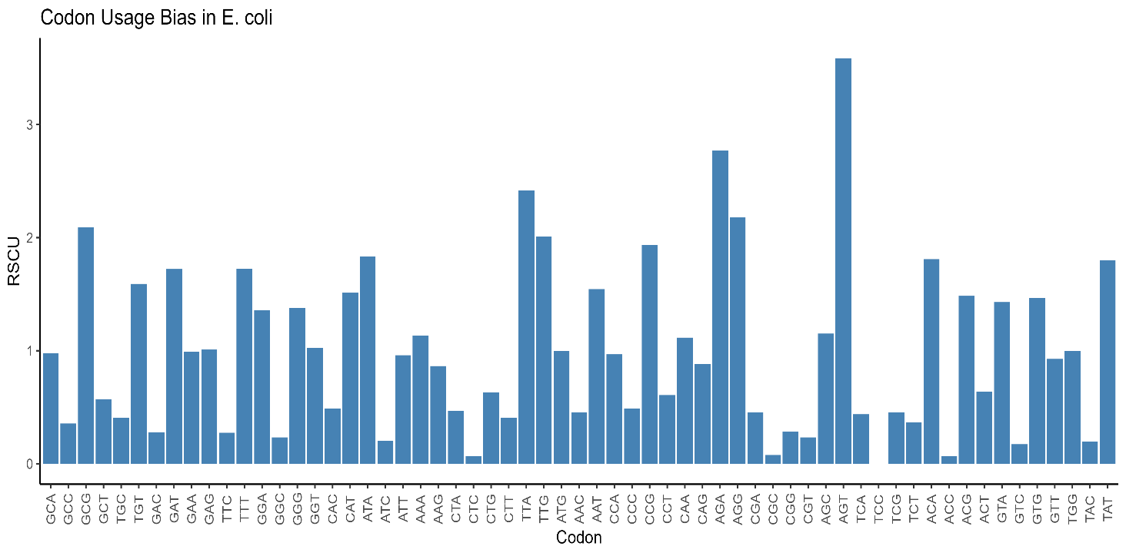
Figure 1. Relative synonymous codon usage (RSCU) values calculated across functional coding sequences of Escherichia coli. RSCU values greater than 1 indicate codons used more frequently than expected under equal synonymous usage, whereas values less than 1 indicate underrepresented codons. The figure illustrates substantial non-uniform usage of synonymous codons across the genome

Figure 2: Standardized residuals of synonymous codons across amino acids
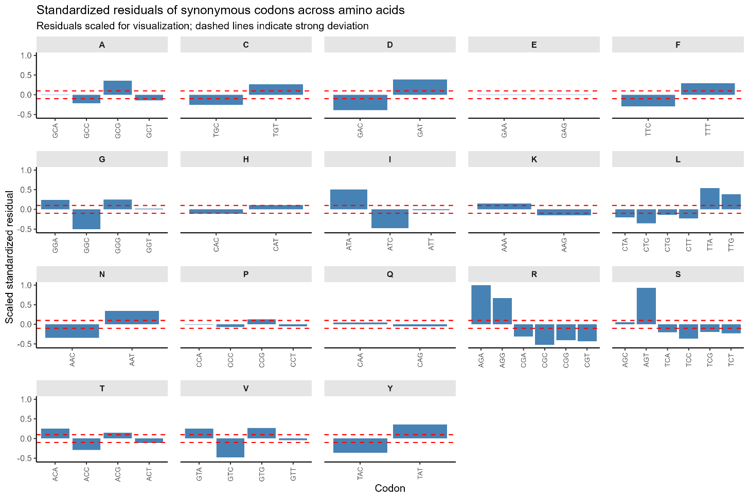
Figure 2. Standardized residuals from chi-square goodness-of-fit tests for synonymous codon usage, shown separately for each amino acid. Residuals indicate the contribution of individual codons to deviations from equal synonymous usage. Dashed horizontal lines denote thresholds for strong deviation. Positive residuals indicate overrepresented codons, whereas negative residuals indicate underrepresented codons.

Figure 3. ENC–GC3 plot of E. coli coding sequences
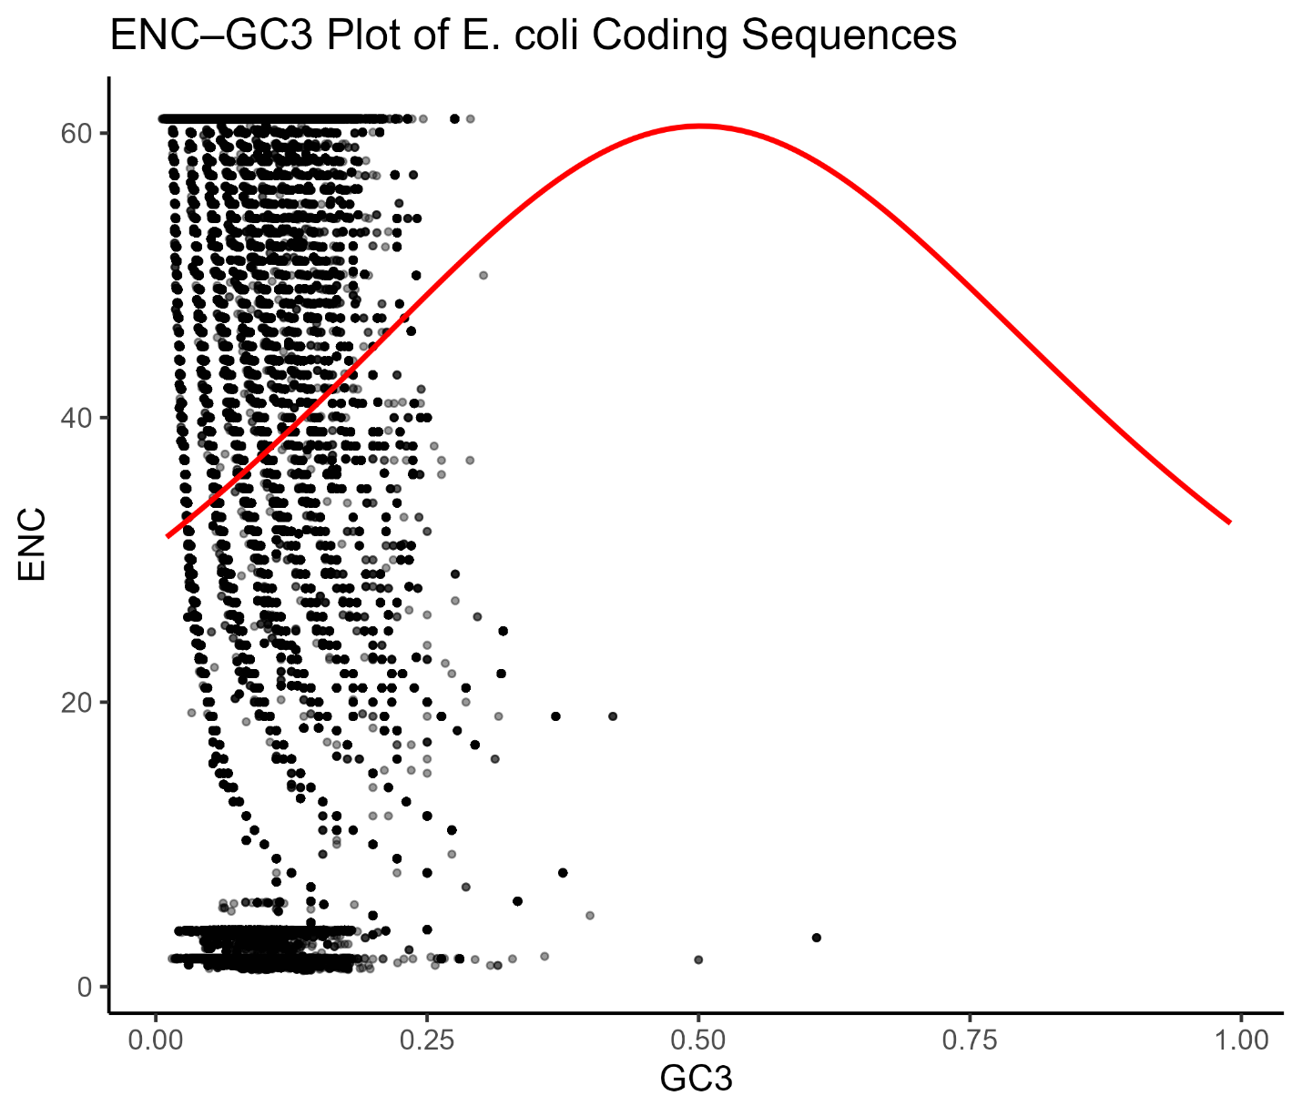
Figure 3. Relationship between the effective number of codons (ENC) and GC content at the third codon position (GC3) for E. coli coding sequences. Points represent individual genes. The red curve shows the neutral expectation under a mutational bias model as defined by Wright (1990). Genes falling substantially below the curve exhibit stronger codon usage bias than expected from GC composition alone.

Discussion:
In this study, we investigated the extent and underlying causes of synonymous codon usage bias in Escherichia coli using a genome-wide dataset of functional coding sequences. By integrating RSCU analysis, chi-square goodness-of-fit tests with standardized residuals, and ENC–GC3 analysis, we assessed whether codon usage bias in E. coli can be explained solely by mutational pressure or whether natural selection plays a dominant role. Genome-wide RSCU analysis revealed substantial non-random usage of synonymous codons across many amino acids. Several codons were consistently overrepresented, while others were strongly underrepresented, indicating clear codon preferences rather than uniform synonymous usage. These patterns suggest that synonymous codon usage in E. coli is structured and constrained rather than random. Chi-square goodness-of-fit tests confirmed that these deviations from equal synonymous usage were statistically significant for most amino acids. Standardized residuals further demonstrated that codon usage bias is driven by a small subset of preferred codons within each synonymous codon family. Importantly, this codon-level resolution shows that bias is not evenly distributed across codons but instead reflects selective enrichment or avoidance of specific synonymous codons. ENC–GC3 analysis provided insight into the evolutionary forces underlying these patterns. Under a purely mutational model, ENC values are expected to follow a predictable relationship with GC3. However, many E. coli genes deviated substantially below the neutral expectation curve, indicating stronger codon usage bias than can be explained by nucleotide composition alone. Moreover, genes with similar GC3 values exhibited a wide range of ENC values, suggesting heterogeneity in codon bias that is inconsistent with mutation-driven explanations. Together, these results support a dominant role for natural selection in shaping synonymous codon usage bias in E. coli. In bacteria, translational selection is thought to favor codons that correspond to abundant tRNAs, thereby improving translational efficiency and accuracy. The strong codon-specific biases observed here are consistent with this model and align with previous studies demonstrating the functional consequences of synonymous codon choice. While this study focused on genome-wide patterns, future work could explore how codon usage bias varies with gene expression level, functional category, or growth conditions. Additionally, extending this analysis to other bacterial species would allow a comparative assessment of how selection and mutation interact to shape codon usage across taxa.
Conclusion:
This study provides a genome-wide assessment of synonymous codon usage bias in Escherichia coli using multiple complementary analytical approaches. Relative synonymous codon usage analysis revealed widespread non-random codon usage across functional genes, and statistical testing confirmed that these patterns significantly deviate from equal synonymous usage. Codon-specific analyses further demonstrated that bias is driven by preferential use of particular synonymous codons rather than uniform shifts across codon families. ENC–GC3 analysis showed that many E. coli genes exhibit stronger codon usage bias than expected from GC composition alone, indicating that mutational pressure cannot fully account for the observed patterns. Instead, the results are most consistent with the action of natural selection acting on synonymous sites, likely through translational constraints. Together, these findings demonstrate that synonymous codon usage in E. coli is shaped predominantly by selective forces rather than neutral mutation alone. This work highlights the evolutionary and functional significance of codon choice and provides a framework for extending codon usage analyses to other organisms and genomic contexts.
References:
Plotkin, J. B., & Kudla, G. (2011). Synonymous but not the same: the causes and consequences of codon bias. Nature Reviews Genetics, 12(1), 32–42. https://doi.org/10.1038/nrg2899
Wright, F. (1990). The effective number of codons used in a gene. Gene, 87(1), 23–29. https://doi.org/10.1016/0378-1119(90)90491-9

